
AY 2022/23 Semester 1 CC0006 T10 Group 29
Fast Fashion Industry
Responsible Consumption and Production
Kevan Seow Xu Long (U2121069H) Nadya Binte Mohammed Yazid (U2130695K) Seah Xiao Jun (U2140850F) Tay Jing Rui Jaryl (U2122318K) Thin Pwint Phyu (U2111672C)
Word Counts: 2128 words Date: 16 November 2022

Abstract
The fast fashion industry is one of the most unsustainable industries worldwide, generating millions of tonnes of waste every year, yet it is a major contributor in the global economy today. How do we balance economic growth and the threats it might give to our society and environment? Through this report, we aim to further understand the issues caused by this industry and come up with innovative and feasible solutions to address the problem. This report focuses on the current consumption and production of the fast fashion industry in three aspects - environment, society and economy. This report also examines the limitations of existing solutions. The research was mainly conducted through literature review and secondary research. Research and findings led to analysis of consumption and production in the fast fashion industry against the Triple Bottom Line framework. This section raises questions about the difficulty in minimising environmental impacts without impacting the economic benefits generated. In addition, there is a need to establish a “correct” moral concept, such as purchasing behaviour, to promote sustainable habits within the industry. Our findings provide the initial step and foundation to structure the importance of reducing clothing consumption and expand to feasible recommendations that individuals can easily achieve. Small changes can make a big difference. A simple approach adopted by a large community is impactful in influencing the industry.

Table of Contents
Abstract 2
Introduction and Literature Review 4
Methodology 5
Findings and Discussions 6
1. Environment 6
2. Social 7
3. Economy 7
4. Interrelations of the Systems 8
5. Goals to Achieve 8
6. Stakeholders Analysis 9
Recommendations 10
Conclusion 12
References 13
Appendix 16

Appendix A: Detail of CRAAP Test 16

Introduction and Literature Review
The fashion industry is one of the most unsustainable global industries due to the extensive supply chain network formed by lack of regulations and emergence of fast fashion in recent years. Fashion and textile products account for 137,000 tonnes of waste in Singapore alone, (NEA, 2021) and 92 million tonnes globally every year (BBC, 2020). Hence, the scope of this report includes an analysis of the fast fashion industry’s impact worldwide and recommends innovative solutions feasible in Singapore to reduce the negative consequences of the industry.
The United Nations (UN) formed the UN Alliance for Sustainable Fashion to
collaborate with stakeholders, and promote projects and policies that contribute to achieving the Sustainable Development Goals. They focus on multi-stakeholder initiatives, private sector partnerships, corporate responsibility campaigns, and value chain development projects (Meier, 2021).
Singapore has also shown immense support for sustainable fashion through initiatives by the Singapore Fashion Council, consistently promoting environmentally friendly business practices while diversifying fashion and textile locally and internationally (SFC, 2021). They identify common areas of concern in enterprises and possible solutions to analyse and capitalise on green efforts. Furthermore, they work with communities to raise awareness of sustainable options in the local fashion scene. Their “Be The Change” program aimed to empower stakeholders to play a part in reducing their carbon footprint.
However, apart from the environment, sustainable fashion also encompasses ethical production, including labour. It is challenging to address the human rights dimension due to complex supply chains (Cerny-Scanlon and Agnes 2016; WEF 2021). The industry employs up to 300 million people, many of whom are women working at the bottom of the system, posing higher risks of occupational injuries and exposure to hazardous chemicals.
In support of this, the Alliance's vision is to improve working conditions and remuneration for workers. The International Labour Organization works with the UN to promote gender equality in the Asian textile industry through social dialogues, strengthening knowledge and good practices among stakeholders. Their scope of work also includes violence and harassment at work (Meier, 2021).

Methodology
To evaluate the validity and credibility, the sources' criteria follow the CRAAP test, including currency, relevancy, authority, accuracy and purpose (see Appendix A). Search terms were used to pinpoint our articles. The “AND” command combined these terms in different ways to streamline our search results. Preliminary information and data were retrieved from the UN's official website while secondary data was collected from Google Scholar and the NTU library database. The "Snowballing" method, where the data and articles in referenced lists are further explored, was utilised to extend the search or examine original research that generated the data.

Findings and Discussions
To investigate responsible consumption and production of the industry, three pillars, including environmental, social, and economic, are analysed for their impacts from a global perspective.

1. Environment
The fashion industry causes detrimental impacts on the environment in aspects of water, air and waste. Firstly, around 93 billion cubic meters of water are used yearly for fashion, equivalent to meeting approximately 5 million people’s water needs. Water pollutants from the manufacturing of clothing contribute to around 20% of water pollution, consisting of more than 15,000 chemicals, some of which can lead to severe diseases and deaths (World Bank Group, 2019).
Secondly, the fast fashion industry contributes 10% to greenhouse gas emissions annually from factories and exportation. Different amounts of energy are exhausted depending on the manufacturer. For example, China’s production can account for 40% more carbon footprint than Turkey and Europe as they mainly rely on coal-based power.
Lastly, the waste generated is massive. About 85% of textiles produced end up in landfills yearly, including pre-consumer and post-consumer textile waste (Ross, 2021). Pre-consumer textile waste is generated during the manufacturing process or unsold products. Waste during the manufacturing process is caused by gaps in communication between designers and manufacturers. Unsold products took up around one-third of all imported closings even at discounted prices (Mowbray, 2016). Post-consumer textile waste comprises approximately 60% of around 150 billion garments produced globally. In 2015, only 15% of the discarded garments were collected for recycling purposes, and less than 1% were recycled in similar quality applications. Although recycling textile waste is an effective method to reduce overall waste, few adopt it (Niinimäki et al., 2020). The severity of widespread environmental impacts depends on the countries’ reliance on manufacturing textiles, but textile waste is discovered worldwide.

2. Social
Fast fashion shifts consumers' perceptions and purchasing behaviours as companies brand themselves as cost-friendly, with faster delivery. Compared to the past, the consumption rate has increased, but products are worn fewer times per item. The fast fashion phenomenon started before 2000 when the growth of clothing production was estimated to be 2% annually. However, global clothing consumption is predicted to reach 102 million tonnes by 2030, almost twice the clothing produced by fashion brands between the pre-2000s and today. The competitiveness within the industry and the rise in demand have pushed the prices lower than ever. As a result, even when clothing consumption spiked, there was a 25% decrease in clothing and footwear expenditure in the EU and UK from the 1950s to 2020
(Niinimäki et al., 2020).
To meet mass customer demands, the industry tends to practise micro-trending, which encourages companies to participate in unethical labour practices such as hiring underage children and exploiting labourers. Low labour costs are preferred to maximise profit earned. Although the fashion industry employs more than 300 million people, including approximately 75 million factory workers worldwide, less than 2% make a living wage, pushing them into poverty (Ross, 2021). Moreover, children in developing countries are the key target for their low-cost and small hands, suitable for tasks such as cotton picking. According to UNICEF, 60% of workers working at mills in India were underage when starting work (Moulds, 2012). Unethical labour practices are sometimes unexposed to companies' headquarters due to the complexity of their supply chain, customer demand and loose regulation in some developing countries. It is a prominent issue where the fast fashion industry is a major cause of labour exploitation.

3. Economy
The global fast fashion industry is a mass market, valued at nearly $68,634.9 million in 2020 (Smith, 2022). However, due to COVID-19, there has been a 20% decline in revenue. An estimated 7% of the company is driven entirely out of the industry. If a business were to invest in the sustainable fashion industry through a circular system, there would be USD$560 billion of economic opportunity (Fashion and the Circular Economy, 2019).
Fast fashion dramatically benefits the economy through job creation and money generated (Swatski, 2021). The expected compound annual growth rate of 5.3% indicates possibilities for this industry to gain more profit and growth (Smith, 2022). To show the boost of minimum wage by the fashion industry, the GDP of the U.S. and Cambodia can be compared, where the GDP was $18.57 trillion and $20.2 billion in 2016, respectively.
Cambodians have lower incomes but higher GDP (Parrish, 2018).

4. Interrelations of the Systems
Fast fashion emphasises quantity over quality, encouraging overconsumption and irresponsible production with short product life cycles. The trade-off is between economic growth and ethical consumerism. The advantages of the industry include economic gain and job creation, while the disadvantages include exploitation of labour and environmental impacts. The question is whether to support consumerism or the environment and whether it is possible to protect consumers' interests and attain economic benefits while eliminating environmental destruction, a scale complicated to balance. Thus, the industry has to slow down and reflect on past, current and future involvement.

5. Goals to Achieve
The findings reveal the fashion industry’s fast expansion and slow improvement in sustainability practice. To achieve sustainability effectively and efficiently, the goals to achieve are — limits to growth, cyclical approach, and waste in focus.
Firstly, limits to growth refer to minimising consumption and reforming customers’ purchasing behaviour, emphasising quality over quantity, and lowering customers' demand, thus limiting production.
Secondly, the cyclical approach minimises waste through rental clothing, extending product life, and recycling. The extension of product life can be accomplished by repair service and second-hand sales or higher quality products. As only 1% of garments are recycled (Niinimäki et al., 2020), concepts of the circular fashion industry can be promoted, like discarding unwanted clothes in specific bins.
Lastly, waste in focus is where proactive and reactive strategies are utilised simultaneously. Proactive strategies refer to preventing and reducing waste that occurs during production and manufacturing. Reactive strategies relate to the strategic actions taken after the clothes are discarded, including reuse, recycling, and disposal.

6. Stakeholders Analysis
Figure 1 shows stakeholders' actions contributing to a more sustainable fashion industry. It is a combined effort required to form a successful transition from current fast fashion to sustainable fashion without impacting worldwide economic growth.
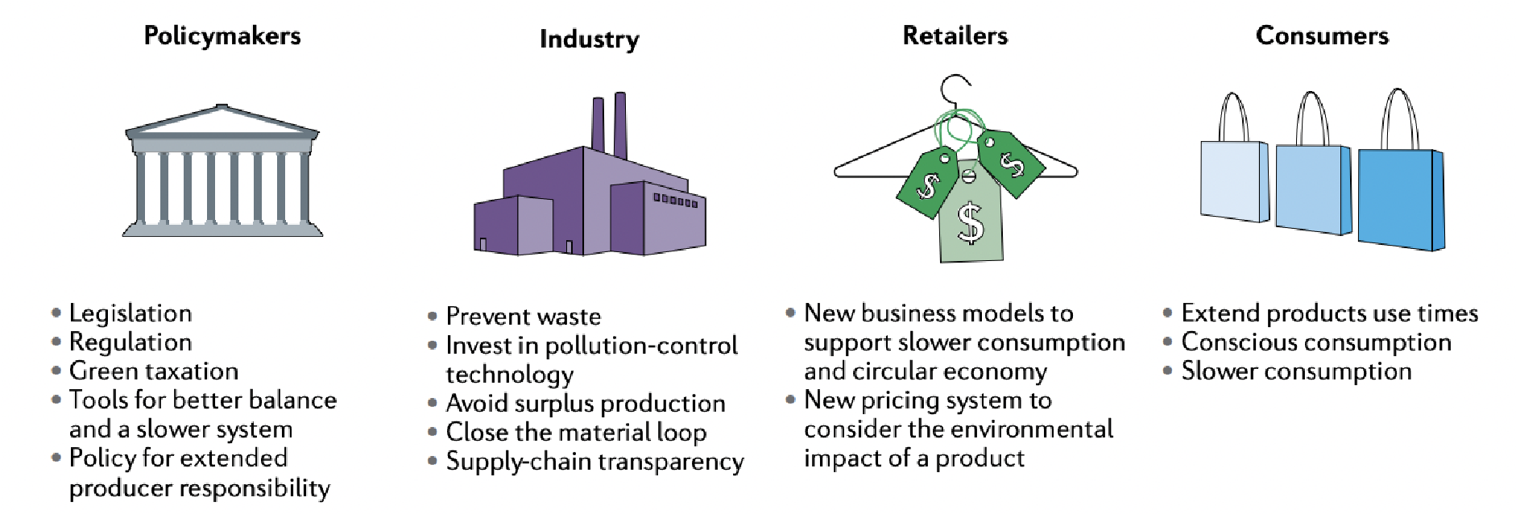
Figure 1. Stakeholders’ Actions (Niinimäki et al., 2020)

Recommendations
Suppliers adopt the fast fashion model due to its high profitability and production of goods at a cheap price due to high demand. This can be curbed by implementing tariffs on the production and export of clothing goods. Tariff-rate quota introduces tariff prices according to the number of goods; the more you produce, the higher the tariff. This increases production costs, targeting the root cause of fast fashion trends. With rising costs, producers will either bear costs or pass them down to consumers. If they were to bear the cost, the unit cost per product would rise. At the same operating level, they will be producing lesser goods. Alternatively, if producers pass the cost down to consumers, a rise in prices will lead to a fall in demand. Governments can apply this pressure to exports and imports of textiles as they are usually produced in third-world countries before being shipped out to fast fashion brands. Alternatively, we could tax brands based on the number of goods sold. Fast fashion will lose its appeal of being cheap while still fashionable and, over time, reduce the market size.
Another key factor that makes fast fashion so unsustainable is its production process. About half the entire clothing produced is made up of cotton, which has a significant impact on the environment. Cotton production uses large amounts of water, destroys soil through pesticides and monoculture farming, and pollutes water sources (WWF, 2022). Meanwhile, dyeing processes pollute water supplies affecting plant and marine life in the area (Bick et al., 2018). Pledges can be taken to educate and switch over to more sustainable production methods. Fast fashion brands can be forced to pledge to these causes and use only suppliers that work with these initiatives through legislation to help curb the impact of fast fashion on the environment. The World Wildlife Fund has launched a campaign called the “Better Cotton Initiative”. The Better Cotton Initiative has led to a significant decrease in the use of fertilisers and pesticides while also improving labour conditions and gender equality (Khan et al., 2021). Similar initiatives can be implemented to make the process more sustainable.
Shifting the focus to consumers, the government can implement social movements to raise awareness of the consumption of fast fashion. Fast fashion relies on repeated and impulsive purchases, creating a false sense of urgency (Niinimäki et al., 2020). Having campaigns and social movements to raise awareness lowers the need for consumers to buy so much clothing. It breaks down the sense of urgency, and people tend to decrease their impulse purchases. In 2017, Singapore did a pilot study to promote the return of trays using positive social directors. This led to a significant increase in the number of trays returned, doubling the previous percentage of trays returned (NEA, 2020). Social awareness programs certainly impact changing social behaviour and are effective tools in combating the social aspect of fast fashion.
The disposal of a large number of textiles can also be addressed by introducing clothing recycling bins throughout the country. With fast fashion, consumers create a lot of waste by discarding clothes that are “out of fashion”. Hence, the implementation of collection bins for clothes will help to repurpose the excess clothing and reduce the amount that goes into a landfill. Partnering with social services, used clothes could be given out to the less fortunate. These bins can be placed at convenient spots like within fast fashion stores to promote recycling.

Conclusion
In conclusion, the current fast fashion industry is unsustainable and detrimental to the environment. People’s purchasing decisions are driven by fast pace product launches and demand for quantity over quality. The industry is fast to expand but slow to improve its sustainable initiatives. It is imperative for the world to set distinct goals and guidelines to minimise impacts. Feasible solutions will assist in the difficult task of balancing economic growth with sustainability and preserving the environment.

References
Fashion and the Circular Economy. (2019). Ellen Macarthur Foundation. Retrieved October
12, 2022, from
https://archive.ellenmacarthurfoundation.org/explore/fashion-and-the-circular-econom y
Bick, R., Halsey, E., & Ekenga, C. C. (2018). The global environmental injustice of fast fashion. Environmental Health, 17(1). https://doi.org/10.1186/s12940-018-0433-7
Khan, L., Awan, Z., Imran, A., Saleem, M., Sufyan, F. and Azmat, M., 2021. The Impact of Better Management Practices (BMPs) Among Cotton Farmers in Punjab, Pakistan.
Journal of Agricultural Science, 13(7), p.74.
Khan, S., & Malik, A. (2013). Environmental and health effects of textile industry wastewater. Environmental Deterioration and Human Health, 55–71. https://doi.org/10.1007/978-94-007-7890-0_4
Meier, L. (2021). Synthesis Report on United Nations System-wide Initiatives related to
Fashion. UN Alliance for Sustainable Fashion. https://unfashionalliance.org/
Meriam Library. (2022, July 8). Evaluating Sources: CRAAP. Central Wyoming College.
Retrieved November 14, 2022, from https://libguides.cwc.edu/bias
Moulds, J. (2012). Child labour in the fashion supply chain. The Guardian. Retrieved
November 8, 2022, from https://labs.theguardian.com/unicef-child-labour/
Mowbray, J. (2016, April 21). One third of all clothing 'never sold' | Fashion & Retail News | News. Ecotextile News. Retrieved November 9, 2022, from
https://www.ecotextile.com/2016042122078/fashion-retail-news/one-third-of-all-cloth ing-never-sold.html
NEA. (2020, July 22). NEA Launches Tray Return Programme To Keep Our Hawker Centres Clean. National Environment Agency. Retrieved November 16, 2022, from https://www.nea.gov.sg/media/news/news/index/nea-launches-tray-return-programme
-to-keep-our-hawker-centres-clean
Niinimäki, K., Peters, G., Dahlbo, H., Perry, P., Rissanen, T., & Gwilt, A. (2020). The
Environmental Price of Fast Fashion. Nature Reviews - Earth and Environment.
Retrieved October 12, 2020, from https://doi.org/10.1038/s43017-020-0039-9
Parrish, E. (2018, June 23). Fast Fashion In a Better Light: Its Benefits on the Economy and Across the World. Bear Market. Retrieved November 8, 2022, from
https://bearmarketreview.wordpress.com/2018/06/23/fast-fashion-in-a-better-light-itsbenefits-on-the-economy-and-across-the-world/
Rentle. (2022). Rentle Oy. Retrieved November 8, 2022, from https://www.rentle.io/?utm_medium=cpc&utm_source=google&utm_network=g&ut m_term=rentle&utm_mtype=e&utm_campaign=14810879170&utm_adgroup=13073
5518227&utm_extension=&utm_ad=605664412500&utm_ad_position=&gclid=Cj0
KCQiAmaibBhCAARIsAKUlaKTko7rW-vkqPGw8bcPqbp3eM0
Ritch, E. L. (2020). Transitioning to RESPONSIBLE CONSUMPTION AND PRODUCTION.
https://library.oapen.org/bitstream/handle/20.500.12657/49695/9783038978725.pdf?s equence=1#page=78
Ross, E. (2021, October 28). Fast Fashion Getting Faster: A Look at the Unethical Labor
Practices Sustaining a Growing Industry. Student Briefs. Retrieved November 8,
2022, from
https://studentbriefs.law.gwu.edu/ilpb/2021/10/28/fast-fashion-getting-faster-a-look-at
-the-unethical-labor-practices-sustaining-a-growing-industry/
Singapore Fashion Council. (2022). About the Singapore Fashion Council. Singapore
Fashion Council. https://www.sgfashioncouncil.org.sg/about/
Smith, P. (2022, June 2). Fast fashion market value forecast worldwide 2021-2026. Statista. Retrieved November 8, 2022, from
https://www.statista.com/statistics/1008241/fast-fashion-market-value-forecast-world wide/
Swatski, A. (2021, June 10). The Economic Impact of the Fashion Industry. Fashinnovation. Retrieved November 8, 2022, from
https://fashinnovation.nyc/the-economic-impact-of-the-fashion-industry/
Wear Your Power. (2022). Style Theory. Retrieved November 8, 2022, from https://www.styletheory.co/sg/apparel?utm_content=style%20theory&gclid=Cj0KCQi
AmaibBhCAARIsAKUlaKRxMAjQyi9atLyBal65wkn50dtjKWMUS0xjd621t4wG2l yigXoJp_kaAlX5EALw_wcB
World Bank Group. (2019, September 23). How Much Do Our Wardrobes Cost to the Environment? World Bank. Retrieved October 12, 2022, from
https://www.worldbank.org/en/news/feature/2019/09/23/costo-moda-medio-ambiente
World Wildlife Fund. (2022). Cotton | Industries | WWF. World Wildlife Fund. Retrieved
November 16, 2022, from https://worldwildlife.org/industries/cotton

Appendix
Appendix A: Detail of CRAAP Test
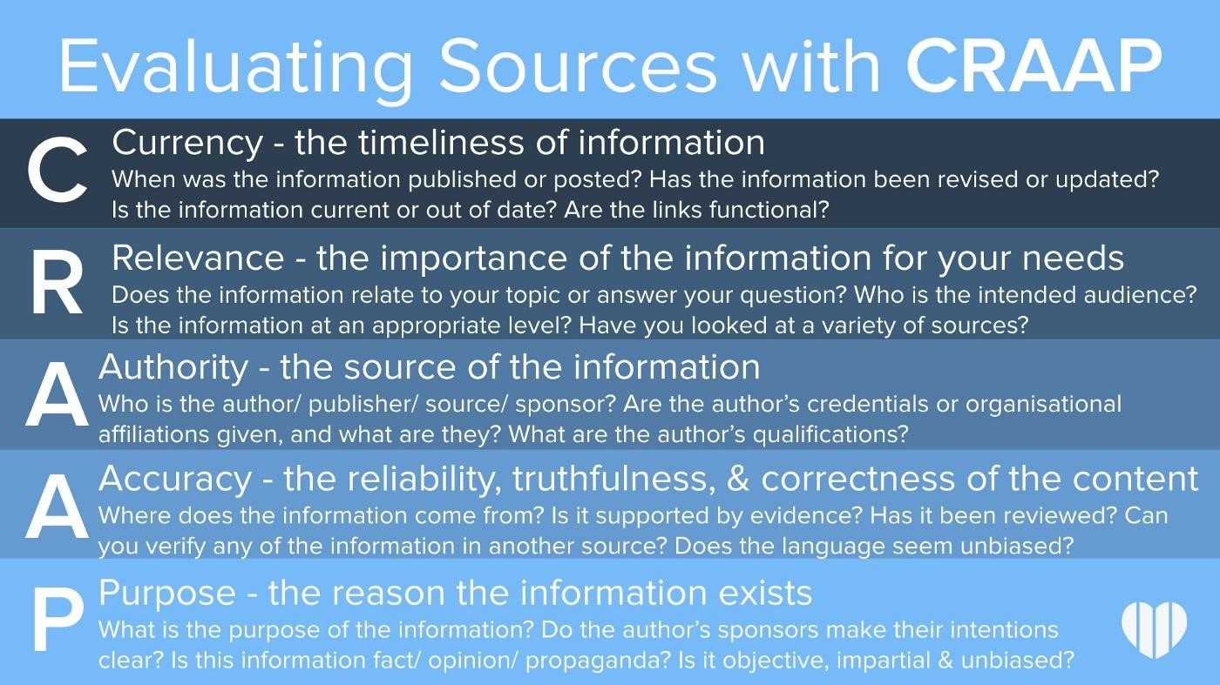
(Meriam Library, 2022)

